Abstract—The purpose of this lab was to create a Drivebot, make four programs, download those programs onto the bot and run them successfully. These programs consisted of driving the bot forward, turning the bot 180 degrees, turning the bot 90 degrees, making a sound, and making the bot drive through a maze without touching any of the maze walls. This was done using a combination of motor on/off commands, rotational sensor commands, LCD display text commands, a sound function and other basic ROBOTC programming.
Lab # 2 - DriveBot
Team Name: The Muffin Stuffers Kit #: 15
Jasen Curtis and Barak Barclay

INTRODUCTION
IN this lab, a castor bot from nxtprograms.com was built to follow sequential motor control instructions and a sound function. All of these functions allowed us to become familiar with writing motor control instructions, wait statements, LCD display control statements and sound functions in the ROBOTC program.

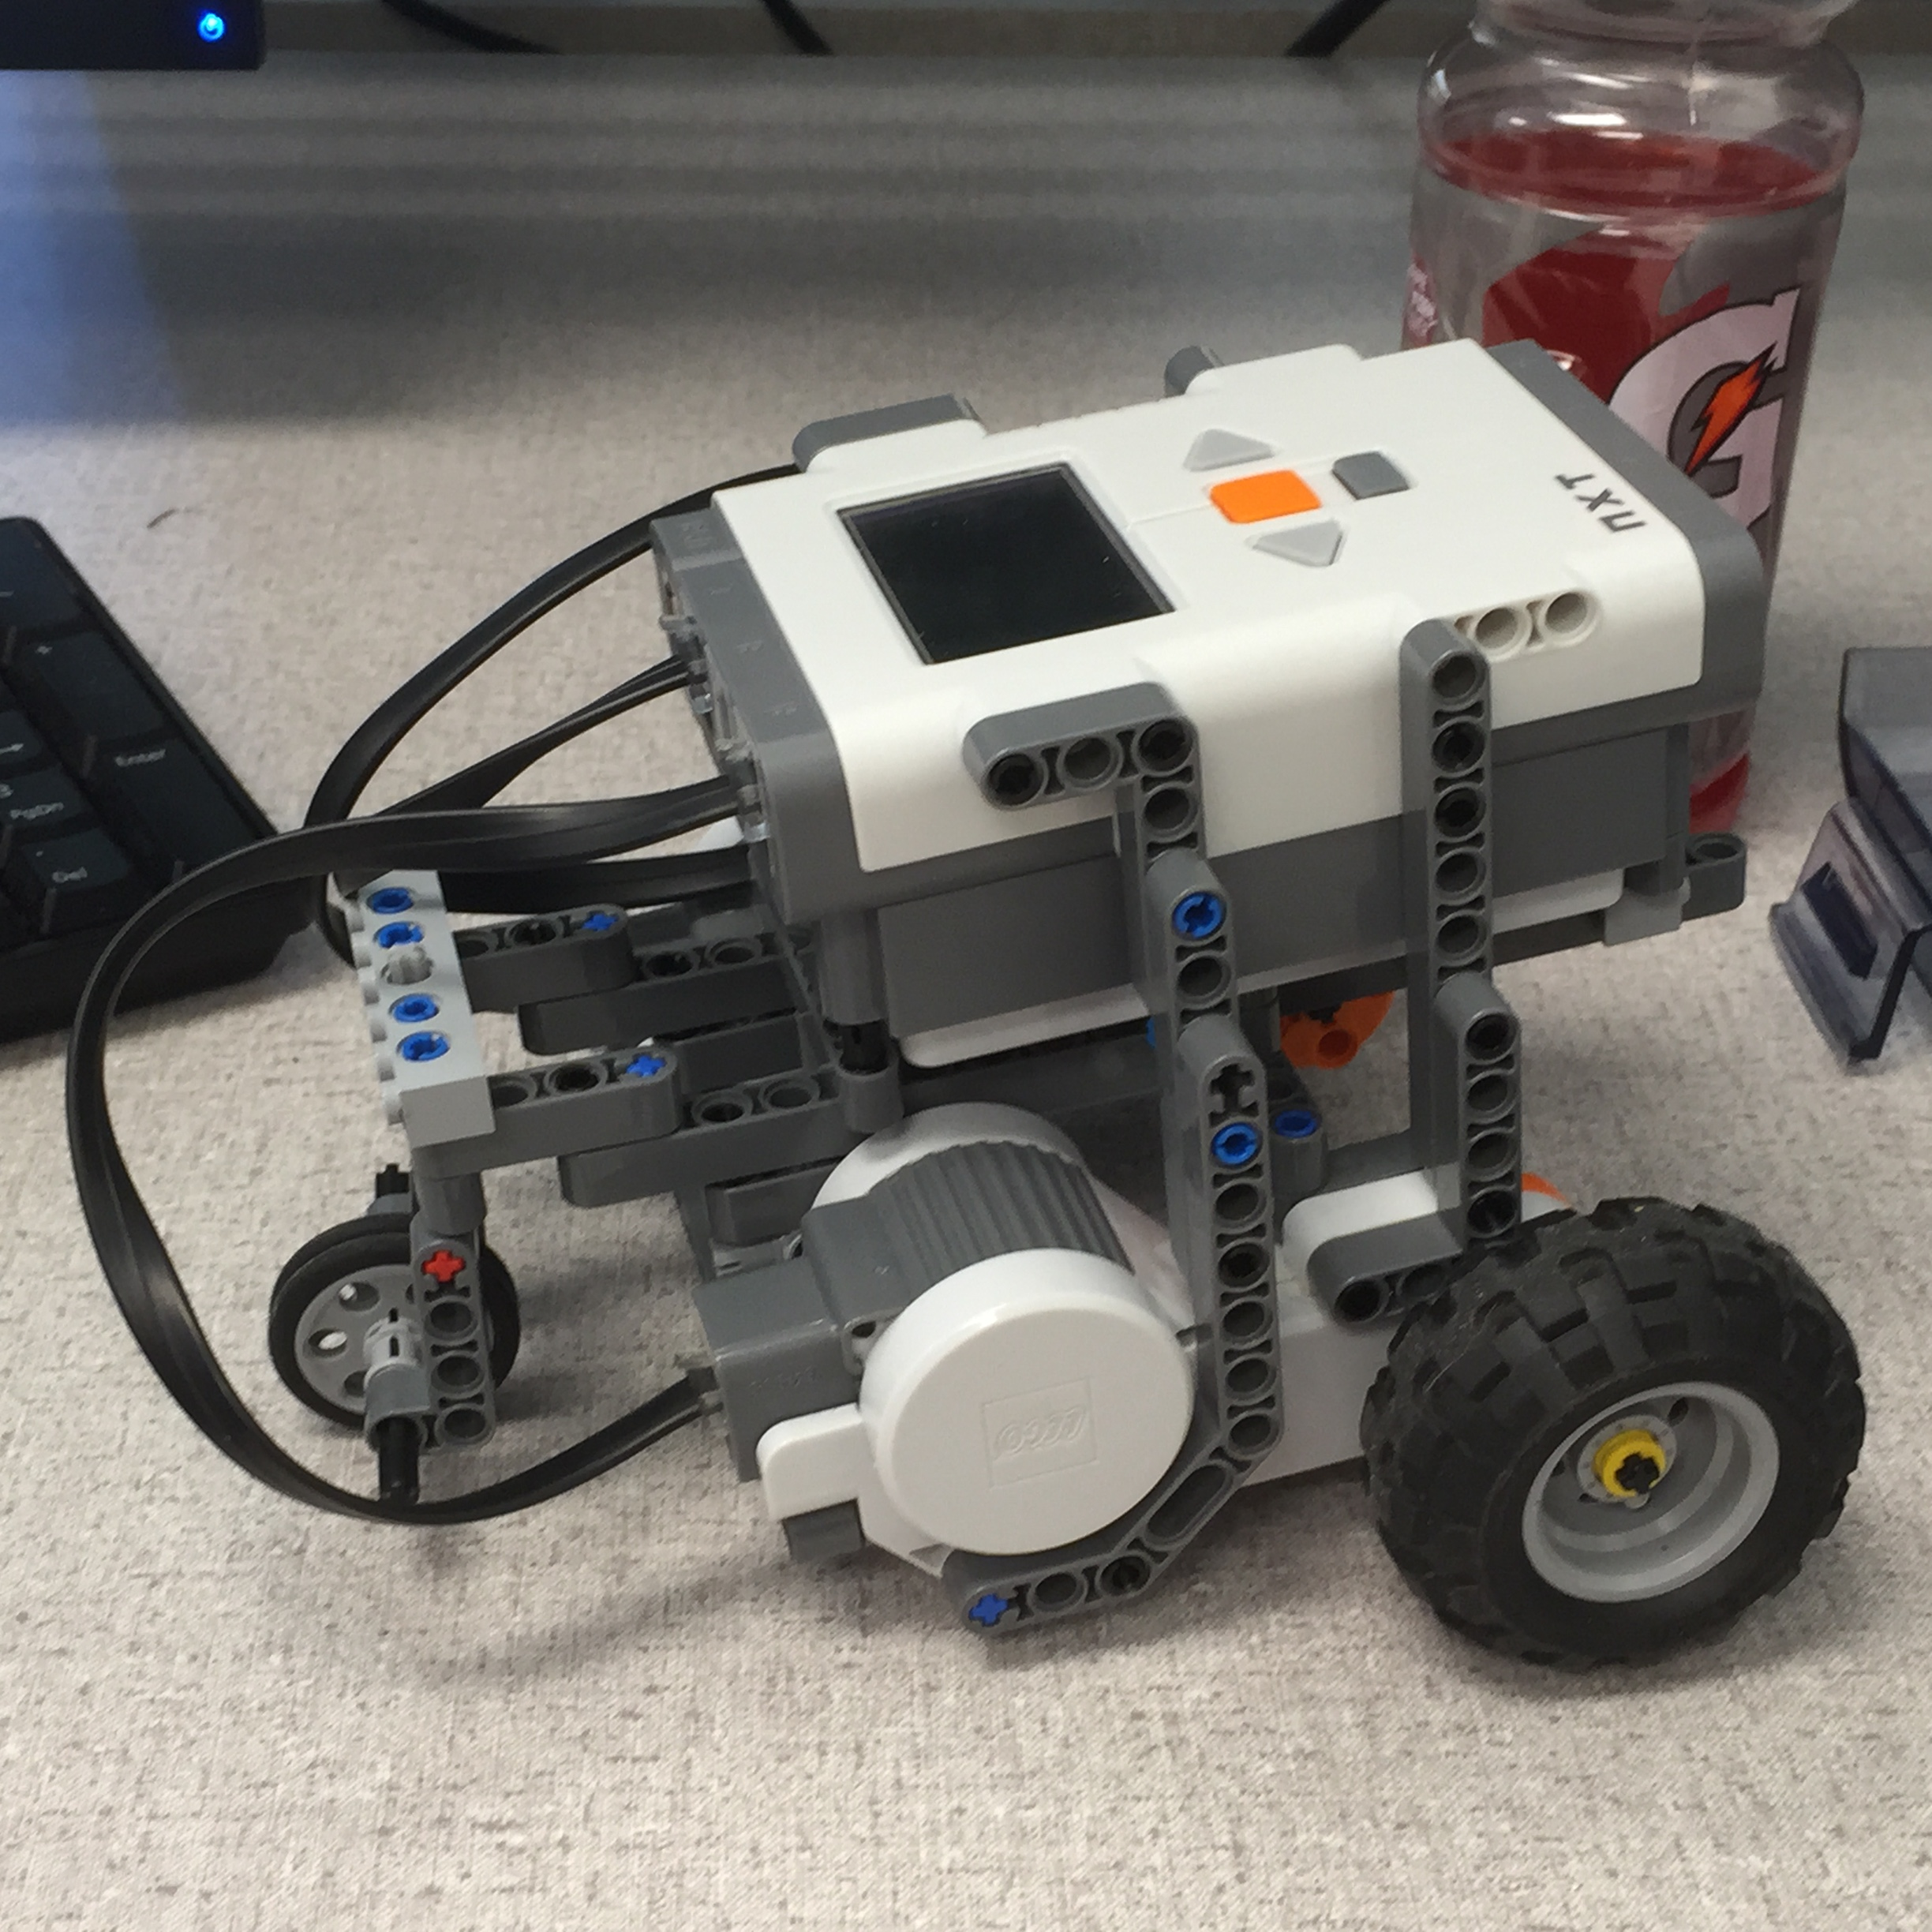
Figure 1. Picture of the Drivebot

Task 1: Drive Down and Back
A simple Drivebot was made before getting into first task. The task consisted driving the bot half of the table length, turning around 180 degrees and returning close to where the bot started. The code for this task was short to become familiar with basic ROBOTC coding. Here are few lines from the program:

motor[motorA]= 50;
motor[motorC]= 50;
wait1Msec (3500);

For three and a half seconds motors A and C were turned on at fifty percent power. After these few lines a similar method was used to turn the bot 180 degrees. That method was to give power to only one of the motors for a certain amount of time after the bot had stopped moving forward.
Algorithm for Task 1:
Task Main
Turn on Motor A & Motor C
Wait time length (for bot to travel half table length)
Turn off Motor A & Motor C
Wait time length (for bot to not move forward and turn at the same time)
Turn on Motor A
Wait time length (for bot turn 180 degrees)
Turn off Motor A
Wait time length (for bot to not move forward and turn at the same time)
Turn on Motor A & Motor C
Wait time length (for bot to travel half table length)
End Task Main

Task 2: Rotational Sensor and LCD Display
For this task the rotational sensors in the motors had to be used and the LCD screen had to show the degree of the angle the rotational sensor measured while the bot was driving. Here is the code that was used for the LCD screen display.

while (nMotorEncoder [motorA] < 900)
motor[motorA]= 50;
displayTextLine (1, "%d",
nMotorEncoder[motorA]);
displayTextLine (2, "%d",
nMotorEncoder[motorC]);

Algorithm for Task 2:
Task Main
Turn on Motor A & Motor C
Wait time length (for bot to travel half table length)
Turn off Motor A & Motor C
Wait time length (for bot to not move forward and turn at the same time)
Set Rotational Sensor to 0
While Rotational Sensor < the value needed to turn halfway
Turn on Motor A
Display text on LCD
End While
Wait time length (for bot turn 180 degrees)
Turn off Motor A
Wait time length (for bot to not move forward and turn at the same time)
Turn on Motor A & Motor C
Wait time length (for bot to travel half table length)
End Task Main

Task 3: 90 Degree Angle and Sound
In this task the bot was made to drive halfway across the robot bullpen, turn 90 degrees toward the whiteboard, drive approximately two feet, turn 180 degrees and play a sound. The code written was pretty similar to the second code except another turn, another drive code for the two feet, a 90 degree turn, and a play sound code was added.

playSound(soundUpwardTones);
wait1Msec (1300);

Algorithm for Task 3:
Task Main
Turn on motor A & C
Wait time
Turn off motor A & C
Set rotational sensor to zero
While Rotational Sensor < the value needed to turn 90 degrees
Turn on Motor A
Display text on LCD
End while
Turn off motor A
Wait time
Turn on motor A & C
Wait time
While Rotational Sensor < the value needed to turn 90 degrees
Turn on Motor A
Display text on LCD
End while
Turn off motor A
Wait time
Play sound
Wait time
End task main

Task 4: The Maze
The program for this task started with the program from the second task, and was added to from there. Once one turn completed successfully, another leg of the maze was added to the code. That was done over and over again until the maze was done.
Algorithm for Task 4:
Copy and paste program from task 2
Copy and paste lines in program
Adjust values to make it through the maze

Results
All of the tasks were accomplished with success. However, a wheel had to be added to the bot, the code had to be debugged at times, and code values needed to be adjusted a lot.

Drive Down and Back
During the first task, the bots mobility was hindered because two wheels, separated by a space, was used to build the bot instead of using only one wheel. This was fixed by re-constructing that part of the bot by putting the wheels together to function as basically one wheel. All of the code was written properly and did not need to be debugged, but the wait1Msec times had to be adjusted in order for the bot to precisely accomplish the task.

Rotational Sensor and LCD Display
The code from the first task was copied and changed to accomplish the second task. Debugging was required because a semicolon was placed on the same line that the while loop began. Debugging was also required in displaying text on the brick screen. Originally, the line number in the displayTextLine code was interpreted to be the line number where the motors stopped. Instead the line number was supposed to be the line number where the text is wanted to appear on the brick screen. Along with the wait1Msec times, the nMotorEncoder angle had to be adjusted.

90 Degree Angle and Sound
The code from the second task was copied and changed to accomplish the third task. The wait times and the nMotorEncoder angle had to be adjusted in this task as well. There was a problem with the sound not playing. After putting the code in the middle of the program, it worked. So, the code was pasted back at the end of the program along with a wait time after it. The problem was the program was ending before the sound could play.

The Maze
The code from the second task was copied and pasted to perform the fourth task. The code for the turns and forward motion was copied several times. No debugging was required for this task. The wait time and nMotorEncoder angles had to be adjusted many times to successfully complete the maze.

Conclusion
The results came out as expected because the bot was built well and the code was written correctly. The Drivebot made for this lab is very similar to the Drawbot described in Baichtal’s Make: Lego and Arduino Projects. If a pencil had been attached to the bot and a big sheet of paper was placed the bullpen, the pencil could have traced the bot’s routes. Given a lot of additional programing, some artwork could have been made from the bot.
In order to avoid the same coding errors in future labs there are a few things that should be considered. Wait time at the end of a program should always be considered so that the program does not end before accomplished its final line(s) of code. Semicolons should not be inserted at the end of a line where a loop, if, else, or switch statement is initiated. What the line number is for the displayTextLine code should be remembered as well.
Appendix
Task 1
task main()
{
motor[motorA]= 50; // Turn motor A on 50%
motor[motorC]= 50; // Turn Motor C on 50%
wait1Msec (3500); // Delay
bFloatDuringInactiveMotorPWM = false; //motors will brake when power is set to "0"
motor[motorA]= 0; // Turn Motor A off
motor[motorC]= 0; // Turn Motor C off
motor[motorA]= 50; // Turn motor A on 50% (Turn around)
wait1Msec (1800); // Delay
motor[motorA]= 0; // Turn Motor A off
wait1Msec (500); // Delay
motor[motorA]= 50; // Turn motor A on 50%
motor[motorC]= 50; // Turn Motor C on 50%
wait1Msec (3500); // Delay
motor[motorA]= 0; // Turn Motor A off
motor[motorC]= 0; // Turn Motor C off
}

Task 2
task main()
{
motor[motorA]= 50; // Turn motor A on 50%
motor[motorC]= 50; // Turn Motor C on 50%
wait1Msec (3250); // Delay
bFloatDuringInactiveMotorPWM = false; //motors will brake when power is set to "0"
motor[motorA]= 0; // Turn Motor A off
motor[motorC]= 0; // Turn Motor C off
nMotorEncoder [motorA] = 0;
while (nMotorEncoder [motorA] < 900)
{
motor[motorA]= 50;
displayTextLine (1, "%d", nMotorEncoder[motorA]);
displayTextLine (2, "%d", nMotorEncoder[motorC]);
}
motor[motorA]= 0; // Turn Motor A off
wait1Msec (800); // Delay
wait1Msec (500); // Delay
motor[motorA]= 50; // Turn motor A on 50%
motor[motorC]= 50; // Turn Motor C on 50%
wait1Msec (3250); // Delay
motor[motorA]= 0; // Turn Motor A off
motor[motorC]= 0; // Turn Motor C off
}

Task 3
task main()
{
motor[motorA]= 50; // Turn motor A on 50%
motor[motorC]= 50; // Turn Motor C on 50%
wait1Msec (3250); // Delay
bFloatDuringInactiveMotorPWM = false; //motors will brake when power is set to "0"
motor[motorA]= 0; // Turn Motor A off
motor[motorC]= 0; // Turn Motor C off
nMotorEncoder [motorA] = 0;
while (nMotorEncoder [motorA] < 450)
{
motor[motorA]= 50;
displayTextLine (1, "%d", nMotorEncoder[motorA]);
displayTextLine (2, "%d", nMotorEncoder[motorC]);
}
motor[motorA]= 0; // Turn Motor A off
wait1Msec (1300); // Delay
motor[motorA]= 50; // Turn motor A on 50%
motor[motorC]= 50; // Turn Motor C on 50%
wait1Msec (1625); // Delay
motor[motorA]= 0; // Turn Motor A off
motor[motorC]= 0; // Turn Motor C off
wait1Msec (1300); // Delay
nMotorEncoder [motorA] = 0;
while (nMotorEncoder [motorA] < 900)
{
motor[motorA]= 50;
displayTextLine (1, "%d", nMotorEncoder[motorA]);
displayTextLine (2, "%d", nMotorEncoder[motorC]);
}
motor[motorA]= 0; // Turn Motor A off
playSound(soundUpwardTones); //Plays the sound "Upward Tones"
wait1Msec (1300); // Delay
}

Task 4
task main()
{
motor[motorA]= 50; // Turn motor A on 50%
motor[motorC]= 50; // Turn Motor C on 50%
wait1Msec (1700); // Delay
bFloatDuringInactiveMotorPWM = false; //motors will brake when power is set to "0"
motor[motorA]= 0; // Turn Motor A off
motor[motorC]= 0; // Turn Motor C off
nMotorEncoder [motorC] = 0;
while (nMotorEncoder [motorC] < 450)
{
motor[motorC]= 50;
displayTextLine (1, "%d", nMotorEncoder[motorA]);
displayTextLine (2, "%d", nMotorEncoder[motorC]);
}
motor[motorC]= 0; // Turn Motor A off
wait1Msec (1500); // Delay
motor[motorA]= 50; // Turn motor A on 50%
motor[motorC]= 50; // Turn Motor C on 50%
wait1Msec (5050); // Delay
motor[motorA]= 0; // Turn Motor A off
motor[motorC]= 0; // Turn Motor C off
nMotorEncoder [motorA] = 0;
while (nMotorEncoder [motorA] < 620)
{
motor[motorA]= 50;
displayTextLine (1, "%d", nMotorEncoder[motorA]);
displayTextLine (2, "%d", nMotorEncoder[motorC]);
}
motor[motorA]= 0; // Turn Motor A off
wait1Msec (1500); // Delay
motor[motorA]= 50; // Turn motor A on 50%
motor[motorC]= 50; // Turn Motor C on 50%
wait1Msec (1200); // Delay
motor[motorA]= 0; // Turn Motor A off
motor[motorC]= 0; // Turn Motor C off
nMotorEncoder [motorA] = 0;
while (nMotorEncoder [motorA] < 620)
{
motor[motorA]= 50;
displayTextLine (1, "%d", nMotorEncoder[motorA]);
displayTextLine (2, "%d", nMotorEncoder[motorC]);
}
motor[motorA]= 0; // Turn Motor A off
wait1Msec (1500); // Delay
motor[motorA]= 50; // Turn motor A on 50%
motor[motorC]= 50; // Turn Motor C on 50%
wait1Msec (5000); // Delay
motor[motorA]= 0; // Turn Motor A off
motor[motorC]= 0; // Turn Motor C off
nMotorEncoder [motorC] = 0;
while (nMotorEncoder [motorC] < 450)
{
motor[motorC]= 50;
displayTextLine (1, "%d", nMotorEncoder[motorA]);
displayTextLine (2, "%d", nMotorEncoder[motorC]);
}
motor[motorC]= 0; // Turn Motor A off
wait1Msec (1500); // Delay
motor[motorA]= 50; // Turn motor A on 50%
motor[motorC]= 50; // Turn Motor C on 50%
wait1Msec (1500); // Delay
motor[motorA]= 0; // Turn Motor A off
motor[motorC]= 0; // Turn Motor C off
}

References
- G. O. Young, “Synthetic structure of industrial plastics (Book style with paper title and editor),” in Plastics, 2nd ed. vol. 3, J. Peters, Ed. New York: McGraw-Hill, 1964, pp. 15–64.
- J. Baichtal, M. Beckler and A. Wolf, Make: Lego and Arduino Projects, Marker Media Books, 1st ed. Canada, Maker Media INC., 2012, ch. 1, pp.1-3.

Barak Barclay: My hobbies include reading, watching movies, watching TV shows, camping, hiking, playing guitar, playing keyboard, skiing, snowboarding, working out, going to concerts, playing video games, swimming and rock climbing. I want to start going rafting, canoeing, kayaking and shooting at archery ranges too. I am an engineering student at UCCS.

Jasen Curtis: I am originally from Ohio. I like to be outdoors either playing sports or fishing. I am looking forward to learning more about robots and want to get my degree in electrical engineering and robotics.

 

